## Usermanual for WebGUI

In the start you will as a user be presented with the following scenario:

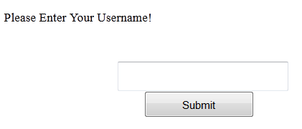

In which you write your name in